
Simplifying surds 2

The Nile in Egypt floods annually in autumn, spreading fertilising silt over the fields. During the time of ancient Egypt, when the floods receded many of the landowners’ boundary marks were washed away. As land survey maps were not in existence at the time, priests re-established the status quo using exact area measurements and verbal descriptions. The priests used a merkhet (a split centre-rib of a palm leaf) for sighting and measuring rods.
What other tool did the priests use to indicate subdivisions of linear measurement?
Find out the answer by solving the following, showing all your working in the space provided. Write the question’s code letter above its solution in the tables on the next page.
Simplify each of the following.
T 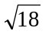 | E 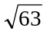
P 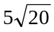 | S 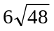
V 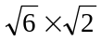 | A 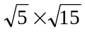
H 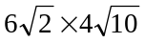 | F 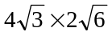
O 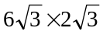 | R 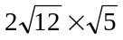



L 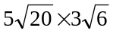 | I 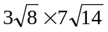
W 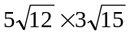 | C 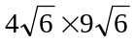
N 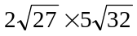 | K 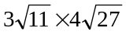

What other tool did the priests use to indicate subdivisions of linear measurement?
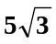 |  | 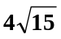 | 36 | 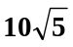 | 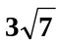 |  | 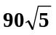 | 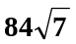 | 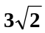 | 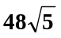
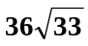 | 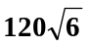 | 36 |  | 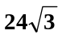
 |  |  | 216 |  | 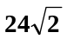 |  | 216
 |  |  | 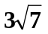 |  | 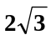 |  | 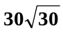

Simplifying surds 2
Answers

T: 3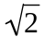, E: 3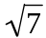, P: 10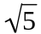, S: 24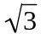, V: 2, A: 5, H: 48, F: 24, O: 36, R: 4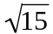,
L: 30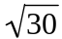, I: 84, W: 90, C: 216, N: 120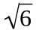, K: 36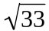,

A ROPE WITH KNOTS AT SPECIFIC INTERVALS

